TPS REPORT - TEAM TENT SALE
 RESERVE YOUR TENT NOW! Seniority and the date your application was received will determine tent location order of selection.
 Limited Space Available – Deadline for application is Monday, April 1st, 2013!
 Please Note: NO Kegs, GRILLS or GLASS BOTTLES OF ANY KIND will be permitted at Curtis Hixon Park. Coolers and bags are subject to search. One company banner may be hung in addition to the team sign. NO TAPE CAN BE USED ON THE TENTS. PLEASE BRING BUNGEE CORDS OR ROPES.

COMPANY NAME: __________________________________________________________________________________________
(Note: This is how your Company Name will appear on your tent sign. Please Print. Sorry, no logos or special fonts)
Team Captain: ______________________________________________________________________________________________
Address/City/State/Zip: ______________________________________________________________________________________
__________________________________________________________________________________________________________
Work Phone: ________________________________ Captain’s E-mail: ________________________________________________

TENT OPTIONS (check one)
◻ $250 - 10’X 10’ Tent recommended for 10-25 people. Includes: 1 Table, 2 Chairs and a sign with Company Name
◻ $600 - 20’X 20’ Tent recommended for 50+ people. Includes: 4 Tables, 8 Chairs, and a sign with Company Name
Extra Chairs - $5 ea. _____ Extra Tables – $20 ea. _____

PAYMENT OPTIONS (check one)
◻ Check: Please fill out form and return with payment to: Beth Shaw LLC Attn: Team Tent Manager
Note: Please make one check payable to: Beth Shaw LLC (Mail to: 5010 Pond Ridge Drive, Riverview, FL 33578)
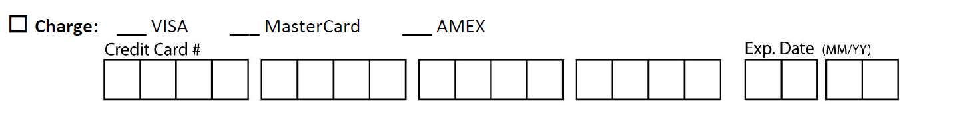

Please fax completed form with Credit Card payment to # 866-353-4694 (Credit Card Orders ONLY, We will call you for the CV code after we get the form)
 No Credit Card Holds.
 Event date is subject to change.
 Refund Policy Refunds will be given to those teams requesting before Monday, April 1st, 2013. Refunds will be the full amount minus a $100 non-refundable processing fee. ***No Refunds will be given after Monday, April 1st, 2013***

We are supporting:

